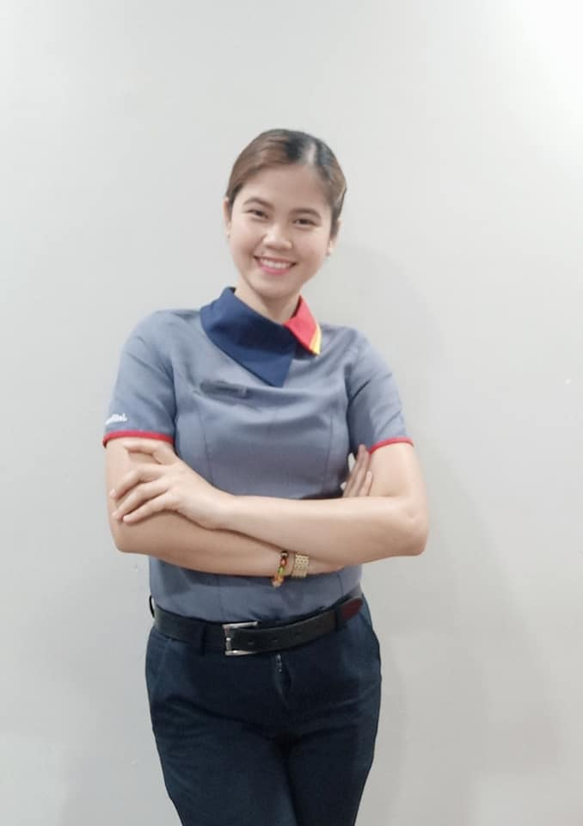**CLAUDINE C. DE GUZMAN**

Block 4, Upper Greenville Calumpang General Santos City, 9500

Contact Number: (63) 949-401-2537

Email Address: deguzmanclaudine20@gmail.com

An experienced as an assistant restaurant manager with a strong interest to increase customer satisfaction and at the same time making sure all of the operations are being done properly, and the staff is well trained and consistently

supported.

**PERSONAL DATA**

Permanent Address: Block 4, Upper Greenville Calumpang General Santos City, 9500

Birth Place: Brgy. San Miguel Malungon Sarangani Province

Gender: Female

Date of Birth: July 14, 1995

Height: 5’4”

Weight: 55 kg

Citizenship: Filipino

Civil Status: Married

Religion: Catholic

**BENEFICIARIES:**

Beneficiary name: Charlie Amper De Guzman

Relationship: Husband

Permanent Address: Block 4, Upper Greenville Calumpang General Santos City, 9500

Mobile Number: (63) 912-192-2367

Beneficiary name: Carl Zian Capuyan Saberon

Relationship: Son

Permanent Address: Block 4, Upper Greenville Calumpang General Santos City, 9500

Mobile Number: N/A

Beneficiary name: Zachariah Owyn Capuyan De Guzman

Relationship: Son

Permanent Address: Block 4, Upper Greenville Calumpang General Santos City, 9500

Mobile Number: N/A

**DEPENDENTS**

Father: Florentino Indac Capuyan Birthday: May 24, 1970

Birth Place: Malungon Sarangani Province

Occupation: Fisherman

Mother: Marilyn Agbon Degamo Birthday:April 22,1976

Birth Place: Malungon Sarangani Province

Occupation: Housewife

**BROTHERS/SISTERS**

Sister: Cathy Jane Degamo Capuyan Birthday: February 4,2001

Birth Place: Malungon Sarangani Province

Civil Status: Single

Occupation: Student

**EDUCATIONAL ATTAINMENT**

Tertiary: **Bachelor of Science in Hotel and Restaurant Management (SY: 2016-2017)**

Golden State College General Santos City

Secondary: **General Santos City National High School (SY: 2010-2011)**

Brgy. Calumpang General Santos City

Elementary: **H.N Cahilsot Elementary School (SY: 2009-2010)**

Brgy. Calumpang General Santos City

**San Miguel Elementary School (SY: 2005-2009)**

Brgy. San Miguel Malungon Sarangani Province

**EMPLOYMENT HISTORY**

**Position: Restaurant Counter Cashier Crew**

Company: Freemont Foods Corporation (Jollibee KCC Mall of Gensan)

Address: Jose Catolico Sr. Ave. Brgy. Lagao General Santos City.

Date: June 21, 2017**-** August 15, 2020

**Job description/ Duties and Responsibilities**

* Sincerest greet customers upon entry, at the lobby area and the counter area consistently.
* Handles cash transactions between customers and the retail store.
* Answer routine billing questions/ menu lists/ issues from the customer.
* Receives and processes all payments according to standard procedures.
* Processed credit cards and debit cards, helping customer use processing equipment.
* Resolve escalated issues with angry customers.
* Inform customers about services available and assesses customer needs.
* Train and sometimes supervise new cashier products assemblers.
* Count the cash in the drawer at the end of the day ensuring cash equal receipts.

**Position: Assistant Restaurant Manager**

Company: Freemont Foods Corporation (Jollibee SM Gensan)

Address: Cor. Santiago Blvd, San Miguel St, General Santos City

Date: June 21, 2017**-** August 15, 2020

**Job description/ Duties and Responsibilities**

**Marketing Incharge (June 2017-August 2020)**

* Supports the Restaurant Manager in achieving sales target.
* Gathers data for marketing program development, provides for marketing support requirements and implements the suggestive selling program.
* Effectively supervised dining floor staff to excellent service and guest satisfaction during hours of operation.

**Position: Assisstant Restaurant Manager**

Company: Premium Taste Trender Company (Jollibee Calumpang Drive-Thru)

Address: Purok Villanueva, Brgy. Calumpang, General Santos City

Date: May 1, 2021 – Up to Present

**Job description/ Duties and Responsibilities**

**Crew Trainer Manager (May 2021-January 2022)**

* Hiring Manager
* Responsible for the training process of all crew.
* Responsible on products update/ new products of Jollibee.
* Conduct training and orientation for all crew.
* Responsible in giving schedules for all trainee.
* Conduct monthly kamustahan with all crew.

**Jollibee Express Delivery Service Manager (July 2021-February 2022)**

* Monitor, analyze, and recommend action plans to achieve targets in sales.
* Effectively supervised Jollibee Express Delivery Service to ensure no customer complaints.
* Responsible in giving schedules to the JEDS crew.
* Responsible in making Monthly Business Reviews.

**Service Quality Manager (February 2022- Up to Present)**

* Monitor, analyze and recommend action plans to achieve targets in sales.
* Gathers data for marketing program development, provides for marketing support requirements and implements the suggestive selling program.
* Supports the Restaurant Manager in achieving the KRA targets through effective management of shift operation.
* Oversaw the service operations.
* Effectively supervised dining floor staff to excellent service and guest satisfaction during hours of operation.
* Guaranteed food quality and 100% customer satisfaction by auditing the menu items and food service guidelines.
* Ensure product availability, especially new products, and achieve strike rate target.
* Responsible in making service crew schedule.
* Ensure Service Area Amenities and Facilities are complete and in good working Condition.
* Ensures service crew, dining and counters are knowledgeable about Standards and execute the Standard Operating Procedures at all times.

**ACHIEVEMENTS**

* **Store Gold Awardee** (2018)

*Jollibee SM Gensan*

* **Beedafirst** (2017-2019)

*Jollibee SM Gensan*

* **Best Go Large Performer (January 10,2015)**

*Jollibee KCC, General Santos City*

* **Rookie of the year (January 10,2015)**

*Jollibee KCC, General Santos City*

* **Most Improve Crew (January 10,2015)**

*Jollibee KCC, General Santos Cit*

**TRAININGS AND SEMINARS ATTENDED**

November 28, 2017 **Integrated Pest Control**

September 12, 2017 **Fundamentals of Restaurant Manager**

August 5, 2018 **Managing Inventory During Shift**

February 1, 2018 **local store Marketing**

November 3, 2018 **Managing utilities**

October 22, 2015 **Multimedia Presentation of Different Front Office Procedures**

Golden State College

December 28, 2015 **Housekeeping NC II**

Golden State College

**OTHER QUALIFICATIONS**

* Proven leadership skills and ability to motivate
* Excellent written and verbal communication skills
* Highly organized and efficient
* Remain calm and professional throughout critical incident
* Ability to work independently or as a part of a team
* Can work under pressure
* Computer literate

**CHARACTER REFERENCES**

**MR. RAYMOND BETONIO**

FOOD SERVICE SUPERVISOR

1 (581)990-1521

[raymondbetonio@yahoo.com](mailto:raymondbetonio@yahoo.com)

6420 rue due gabarit G2J 1N8

**MRS. LENNIE JADE FURTON**

SHIFT SERVICE SUPERVISOR

418-6662

Sept-Iles Quebec City

**MS. JACKIE DELARMENTE**

Restaurant Manager

+639985512857

Jollibee KCC Mall of Gensan

Jackiedelarmente2016@gmail.com

CLAUDINE C. DE GUZMAN

Applicant’s Signature